Dear 6th Grade Students and Families, August 1, 2023

Welcome to 6th grade at Hillsboro-Deering Middle School! We hope you have a relaxing rest of your summer and that you are looking forward to starting a new year at HDMS. We are sure you are a bit nervous for your first year of middle school, but we are here to help you every step of the way!

Although we are close to the end of summer, don’t forget to complete your summer reading assignment. You can also choose to do the Summer BINGO card activities to earn prizes (this is optional). You should have received a paper copy of each assignment before the end of 5th grade, but in case you have access to a device, you can also find the assignments on the “6th Grade 2023-2024” Google Classroom.

The classroom code is: **uwqltil**

**Below is a list of supplies you will need to bring for the first day of school:**

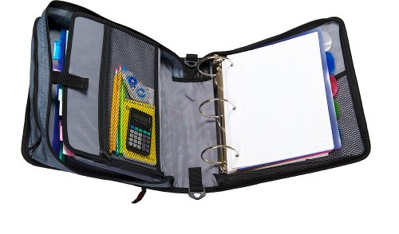

1. **ONE large zipper binder (as pictured) - This will be used to organize anything on paper for every class**
2. **A zipper pencil bag or pencil box**
3. **Pencils/pens**
4. **Dividers (optional)**
5. **EXPO markers (optional)**
6. **Lunch or lunch money**
7. **Water bottle**

Some of the zipper binders come with their own dividers. If you prefer to organize papers in your binder with a folder for each class instead of dividers, not a problem! The goal of the zipper binder is to have one place to organize everything you receive on paper, and to have a safe place for your Chromebook as you travel from class to class.

We hope you enjoy the rest of your summer and we look forward to seeing you on the first day of school. Don’t forget - middle school starts early! The doors open at **7:00 a.m.** and classes begin shortly after that. Start getting to bed earlier so you will be well-rested!

See you soon!

The 6th Grade Team -

Mr. Conway, Mrs. Johnson, Mrs. Martin, Mrs. Conley, and Mrs. Moultroup